Cell Meeting Guide 6 Mar to 12 Mar 2023
ENJOY FRIENDSHIP AND FELLOWSHIP
Refer to the resources page for ice breaker suggestions!

EXALT GOD IN PRAISE AND WORSHIP
Refer to the “Worship” page for song list and guitar chords.

(Pray in tongues as a cell before worship)

EDIFY ONE ANOTHER THROUGH HIS WORD

Sermon Title: Giving the Holy Spirit His Rightful Place
Sermon Date: 5 Mar 2023
Reference Text: John 14:25-26, John 16:12-15
Speaker: Apostle Lawrence Khong

Sermon Recap
- Apart from the Holy Spirit, we cannot know the truth about the Father and experience the reality of God (John 16:13).

- 3 truths were shared about the Holy Spirit:
- The Holy Spirit is a Person - We are not to relate to Holy Spirit as a thing or ignore His existence.
- The Holy Spirit is the Lord God - He is fully God.
- The Holy Spirit is the God in the NOW - Every work of transformation in our lives or in the lives of others is through the work of the Holy Spirit.

- What are the application points for us?
  - We have to grow as Spirit Beings
    - We are primarily Spirit Beings (Gen 2:7)
    - We are to operate as Spirit Beings (Eph 2:6)
    - We are to train ourselves as Spirit Beings (Jude 1:20)

- “When the Holy Spirit ceases to be incidental and again becomes fundamental, the power of the Spirit will be asserted once more among the people called Christians” ~ A.W. Tozer

SHARING
- What have you understood or known about the Holy Spirit before? Do you relate to Him as fully God and as a real Person? Would you speak to Him and hear from Him on a regular basis? Share your experience with the Holy Spirit.
- As Gal 5:25 writes, “If we live in the Spirit, let us also walk in the Spirit.” (NKJV) / “Since we are living by the Spirit, let us follow the Spirit’s leading in every part of our lives.” (NLT)
  - How does this verse apply to you?
  - This week, what change can you make to walk in the Spirit more and become more open to the leading of the Holy Spirit in your life?

PRAYER
- Pray for a greater awareness and desire to walk with the Holy Spirit, and to give Him His rightful place in our lives.

ANNOUNCEMENTS

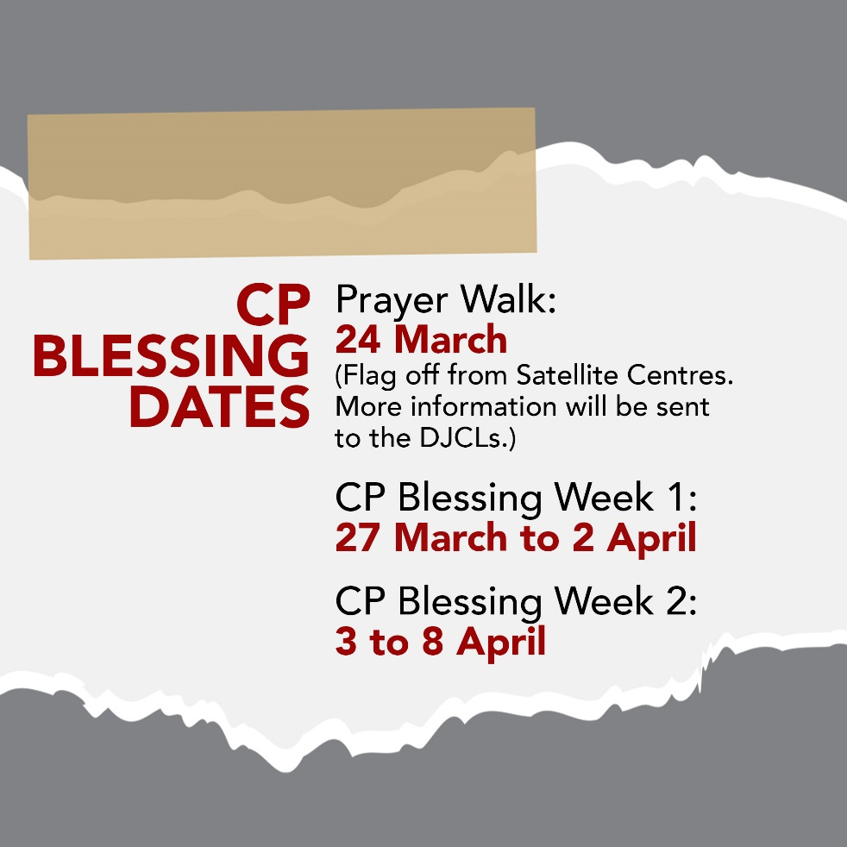

Take note – Prayer Walk (For Leaders):
- All cells will have Prayerwalk on 24 March, Friday, 8.15pm.
- Gather by 8.15pm at your usual CP Satellite Centre (Blk 603/Blk 957/SAC)* or Church L1 Auditorium**
  - *Cells, whose usual meeting point is at blk 574, will meet at Joy Connection (Blk 957)
  - **For cells that collect your CP gifts from church
- Tentative Programme:
  - 8.15pm to 8.40pm: Worship & Short Exhortation @ Satellite Centres/Sumang/L1 Auditorium
  - 8.40pm to 9.20pm: Prayerwalk Designated Route

Please refer to the bulletin for more announcements.

